American Holiday Foods

By: Emma K.

We celebrate many holidays by eating together as a family. We have lots of different foods that we eat. On holidays like Thanksgiving, we give thanks. We get together with family and have a feast. The main course is usually turkey or ham. We eat many vegetables, desserts, and common side foods for North America. We eat green beans, shells with cheese which we call mac and cheese, mashed potatoes, and pies like pumpkin or apple.

We also celebrate Christmas. Most people eat ham or sometimes barbeque. Then just about the same side dishes that we eat for Thanksgiving.

In Tennessee, we eat lots of fried foods. On holidays we usually take a break and eat lots of vegetables.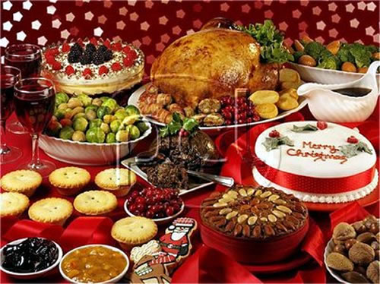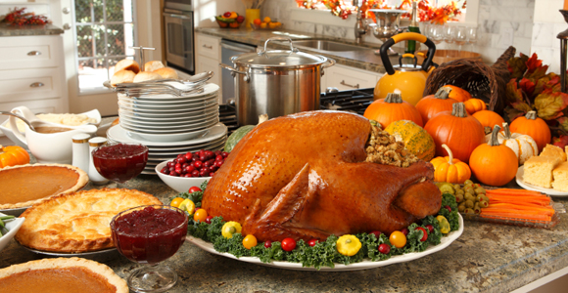

Christmas foods Thanksgiving foods